
ME315 — Machine Learning in Practice
Final Project Report

Machine Learning for Lifestyle-Based Health Assessment: Predicting Calories Burned and Cardiovascular Disease Risk

Lecturer:Dr Kostas Kalogeropoulas & Dr Francesco Panero
Instructor: Phil Chan & Pingfan Su

LSE Student ID:240019294
Date of Submission:10 July 2025
Abstracts
The aim of this project is twofold: to predict the exact number of calories burned based on physiological and exercise parameters, and to classify heart disease based on a patient's medical parameters using different machine learning models. This analysis consists of two parts covering regression and classification.For regression, the following methods were used: OLS, Ridge Regression, Random Forest and XGBoost. For classification, the following methods were used: Logistic Regression, KNN, Decision Tree, Random Forest and Gradient Boosting. OLS, Ridge Regression, Random Forest and Gradient Boosting. The models were evaluated using metrics such as MSE, MAE, RMSE and R² for regression and accuracy and ROC-AUC for classification. The analysis revealed that the XGBoost model was the most effective for regression and the Random Forest model was the most accurate for classification. These results can be used to inform decisions in the field of individual health and heart disease prevention.

Table of Contents
1. Introduction 3
2. Literature review 4
2.1 Regression Task 4
2.2 Classification Task 4
3. Methodology: 5
3.1 Data description 5
3.2 Statistical review of variables 6
3.3 Preparing the data for modelling 8
3.4 Model design and comparison 8
4.Results 9
4.1 Regression Results 9
4.2 Classification Results 10
5.Conclusion: 11
References: 12

1. Introduction
In recent years, there has been a growing interest among people in healthy lifestyles, exercise, and healthcare. Determining the likelihood of developing heart disease and counting calories burned are important issues in health and sports, and demonstrate the potential of machine learning in solving practical problems. This topic is valuable because it is highly relevant to daily life, showing how technology can improve people's quality of life and health. The given study had two objectives:
1) To predict the exact number of calories burned using regression methods;
2) Build a model to classify the presence of heart disease.
To solve these problems, the different models were used, ranging from simple linear models to more complex ensembles. The project compared the models and selected the most accurate one for given issues.

2. Literature review

2.1 Regression Task
Given the rising obesity rates in today's population, there is a growing awareness of the need to maintain a healthy lifestyle, with many studies emphasising the importance of accurately predicting calories burned in the fight against obesity. Nipas et al. (2022) compared OLS, Ridge regression, and Random Forest regression, finding that the Random Forest model was the most accurate. Sebastian et al. (2024) claimed that knowing the exact number of calories burned helps with weight management, dietary adjustments, and appropriate exercise training. To address this issue, scientists applied various machine learning models, each with its own strengths and limitations. According to the Journal of Informatics and Web Engineering (2024), Ridge, Lasso, XGBoost, Random Forest, and XGBoost Light were employed to predict calorie expenditure. The lowest average error (approximately 1.27) was found in the LightGBM model, indicating its high performance in complex data processing. Panwar et al. (2023) showed that XGBoost performed best with low error (MAE = 1.48%) among the tested models (including linear regression, decision tree and random forest).

2.2 Classification Task
Heart diseases remains one of the leading causes of mortality worldwide, which is a pressing problem. However, technological advances in machine learning methods make it possible to identify risks in advance and prolong life. A study by Hassan et al. concluded that the Random Forest model was the most effective at predicting heart disease, achieving an accuracy rate of 96%. Meanwhile, Khan et al. highlighted LightGBM as the most effective model, achieving an accuracy rate of 84.6% and outperforming the other models. Scientists acknowledge the potential of complex models when dealing with intricate medical data, yet emphasise the necessity of further validation prior to their application in clinical medicine.
Overall, ensemble models perform better in both tasks, confirming their usefulness for health and physical activity applications.

3. Methodology:

3.1 Data description
The data for this study was taken from the Kaggle platform (see the attached links). This project used three datasets, two of which were merged for regression analysis, while the third was used for classification.
Calorie Burnt Prediction Dataset: the calorie burnt dataset contained two files: one file contained data on the number of calories burned, and the second file contained information on the physiological and demographic characteristics of individuals, such as gender, age, height, weight, exercise duration, heart rate, and body temperature. The merging was done by user ID, and no missing values or duplicates were found. The merged dataset included 15,000 observations with seven features and a target variable: calories.
Reference for the dataset: https://www.kaggle.com/datasets/fmendes/fmendesdat263xdemos
Heart Disease Dataset: This dataset contains data published in 1988 and taken from four medical centres. The file includes 14 traits, such as age, sex, chest pain type, resting blood sugar, maximum heart rate achieved, exercise-induced angina, etc. The target variable is 'target', which means 0 for absence of heart disease and 1 for presence of heart disease.
Reference for the dataset: https://www.kaggle.com/johnsmith88/heart-disease-dataset

3.2 Statistical review of variables
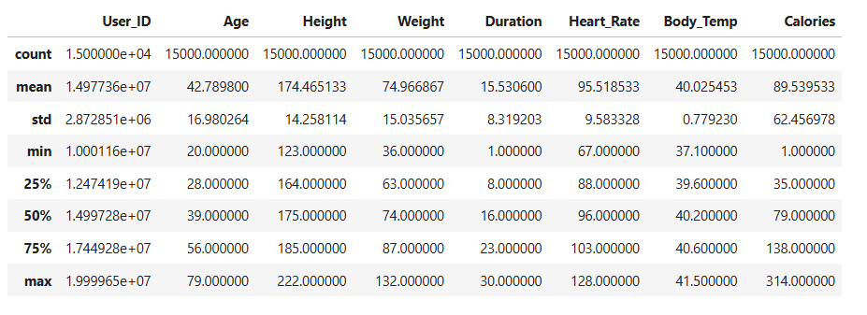
At the start of the dataset, a description was conducted of the main statistics for each trait (see Figure 1). This ensured that all variables were within reasonable limits and that the data were suitable for training purposes. For example, Figure 1 shows that the average age of the participants is approximately 43 years old, with calories burned ranging from 1 to 314 kcal. This wide variation is ideal for training models.
Figure 1
The following graphs were plotted to identify the data structure and outliers:
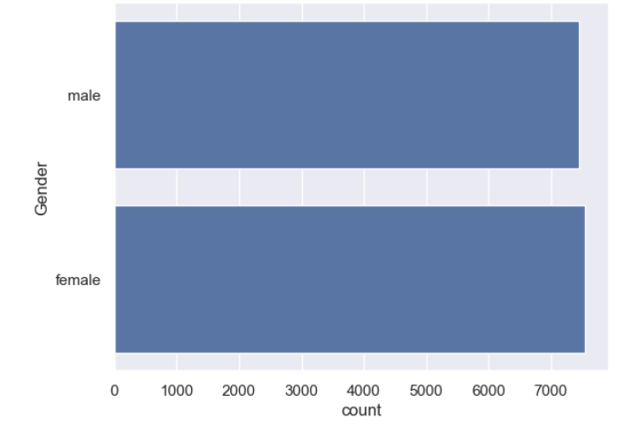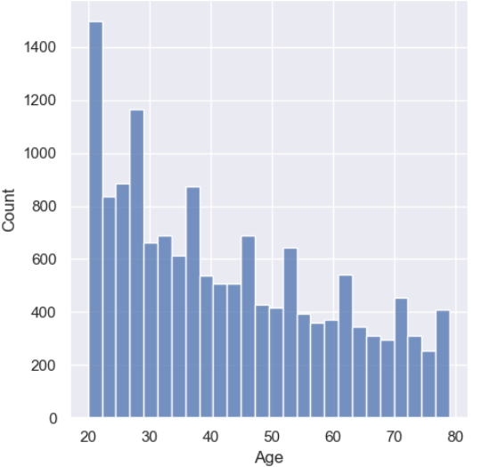
Figure 2 Figure 3

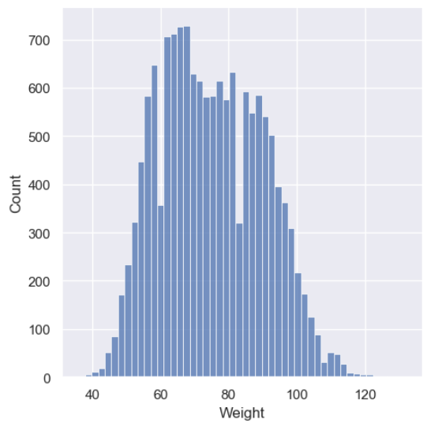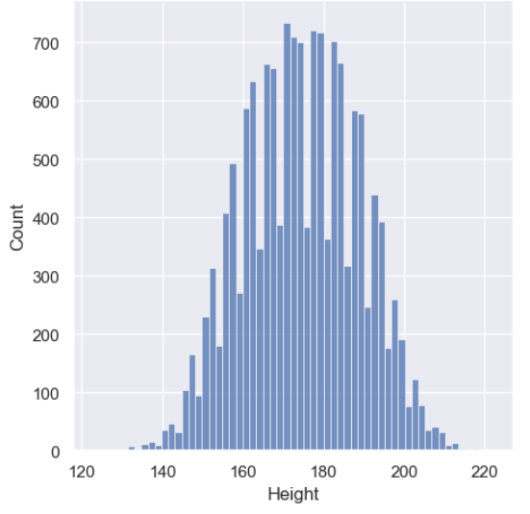
Figure 4 Figure 5

Figure 2 shows that the sample is almost equally divided between males and females, which is important for balanced machine learning.
Figure 3 shows that almost all observations in the sample fall within the 20–50 age range, indicating the presence of both young and old participants.
Figures 4 and 5 show that the height and weight traits follow a normal distribution, which is favourable for the models. The height distribution is symmetrical, peaking at around 175 cm, while the weight distribution peaks at around 70 kg.
A correlation matrix was constructed to determine which attributes are most strongly associated with the target variable.
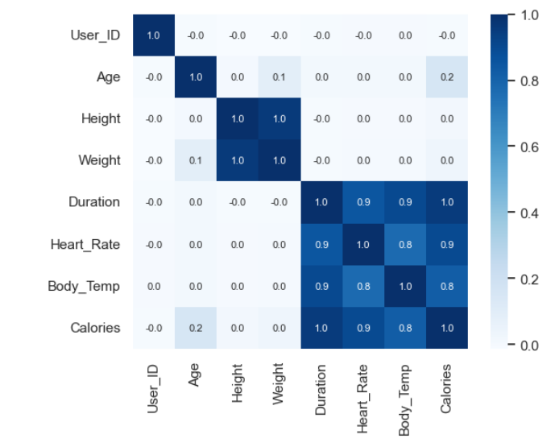
Figure 6
According to Figure 6, we can see that the target variable correlates very strongly with duration (1.0), heart rate (0.9) and body temperature (0.8). The variables age, height and weight show very low correlation, which may indicate that they have little predictive value in linear models.

3.3 Preparing the data for modelling
Data cleaning and preliminary analysis were carried out for the two tasks. By removing duplicates and omissions, the desired features were selected, and the features were standardised using StandardScaler. Categorical features were converted into a numerical format where required. To evaluate the quality of the models on unseen data, the data was divided into a training set (80%) and a test set (20%). Two target variables were generated for the project: calories for regression and target for classification. In the classification task, the target variable was checked for class balance and coded.

3.4 Model design and comparison
Different models were used for the two problems and the main objective was to compare the performance of the various approaches. For regression, the OLS, Ridge Regression, Random Forest and XGBoost methods were used, while for classification, Logistic Regression, K-Nearest Neighbour (KNN) ,Decision Tree, Random Forest and Gradient Boosting were used.
The regression model was evaluated using metrics such as MSE, RMSE, MAE and R², while the classification model was evaluated using metrics such as accuracy and ROC AUC curves.

4.Results

4.1 Regression Results
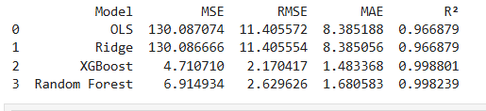
Figure 7
As can be seen from the figure 7, the results for OLS and Ridge were almost identical, which can be explained by the insignificant regularisation parameter in Ridge for this data structure. Therefore, the model did not differ from ordinary regression. These models are well suited to linear relationships but cannot handle complex interactions between variables. The R² value is quite high (about 0.967), but linear models are less flexible than decision trees. It can be seen that the Random Forest model significantly improves upon the results of linear models: the MAE decreases by almost five times, and 99.82% of the variation in calories is explained by all the signs of the independent variables. The best model for this project is the XGBoost Regressor: the MSE is almost 19 times smaller than the OLS model, and the R² value is 0.9988. This method can effectively deal with overtraining, even allowing for flexibility in the models. Decision tree-based models are highly effective in cases of non-linear dependencies and interactions between variables, which linear models cannot account for. In the context of this project, XGBoost can be considered the optimal choice, particularly if prediction accuracy is a priority.
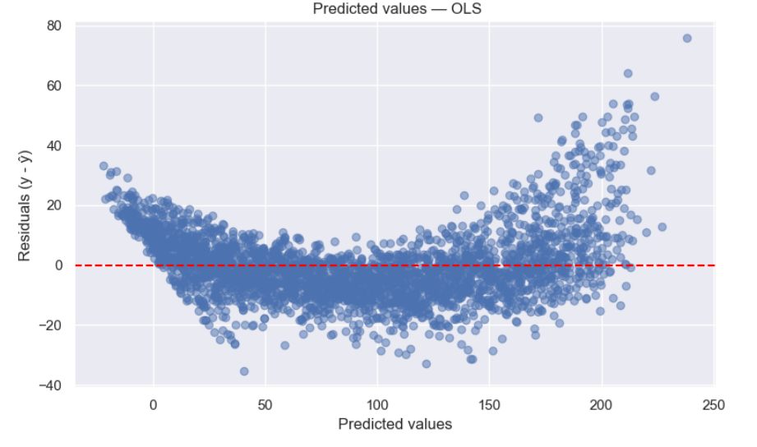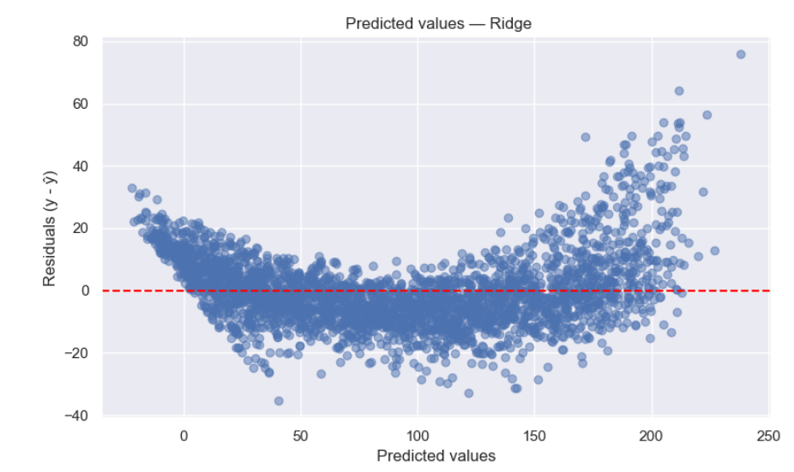
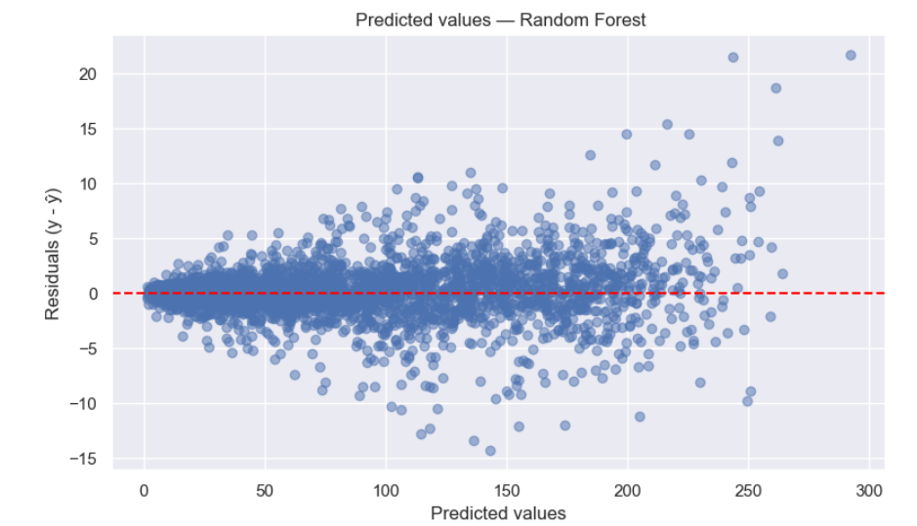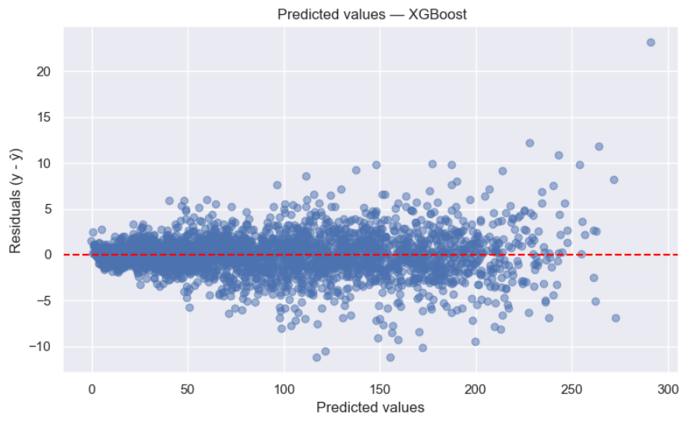
Figure 8
As the figure 8 shows, the linear OLS and Ridge models exhibit a clear U-shaped distribution. This indicates that they are unable to capture nonlinear dependencies in the data. In contrast, the Random Forest and XGBoost models more accurately approximate the complex dependence, showing a random distribution of residuals around zero. This graph illustrates the superiority of tree models over linear models in this regression.

4.2 Classification Results
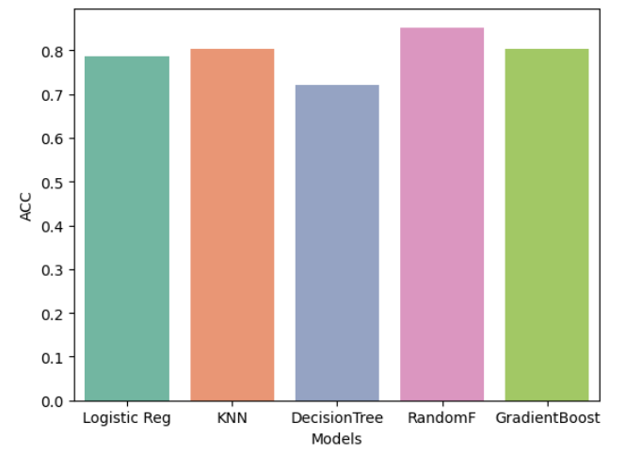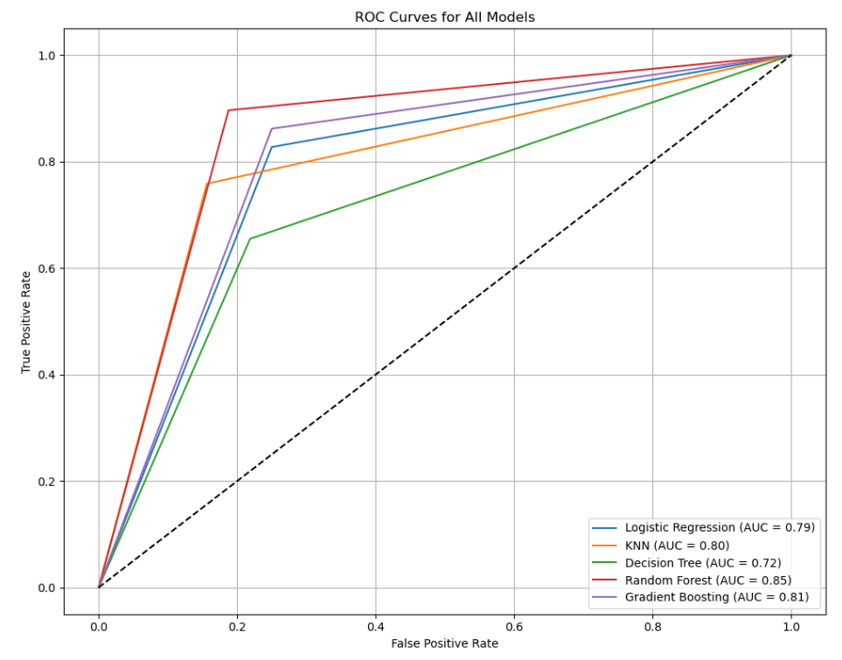
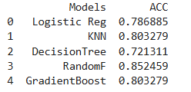
Figure 9 Figure 10

Figure 11
According to the results in the table(Figure 11), Random Forest and Gradient Boosting achieved the highest accuracy of all the models at 85.25% and 80.3% respectively. These models can account for complex and nonlinear dependencies, reducing overfitting by combining several models. Due to a lack of regularisation and a tendency to overfit, Decision Tree achieved the worst result with an accuracy of 72% amon all tested methods. The simplicity of this model makes it interpretable; however, without regularisation, it tends to pick up noise. Logistic regression and K-nearest neighbours (KNN) showed average results, with an accuracy range of 78–80%. KNN showed a slight improvement compared to logistic regression, which can be explained by the fact that the data are clustered with clear separation.
As can be seen from the graph (Figure 10), Random Forest and Gradient Boosting have the highest AUC (more than 0.8) of all the models demonstrating their high ability to distinguish between sick and healthy patients.Meanwhile,Decision Tree has the lowest AUC value of 0.72, indicating overfitting.
In summary,the analysis can conclude that Random Forest is the most accurate and robust model for this task.

5.Conclusion:
This project investigated two vital tasks using machine learning techniques. The first objective was to predict the exact number of calories burned based on certain characteristics, and the next objective was to determine the risk of cardiovascular disease. It should be noted that these two topics are closely related and of great importance in today's world, as they help people to monitor their health, nutrition and physical activity, and to react in time to potential malfunctions in the body.
For the regression task, four models were tested: OLS, Ridge, Random Forest and XGBoost. According to the results of the derived metrics, XGBoost handled the data well and produced the most accurate results, indicating that this model could be used in areas where it is necessary to know the exact number of calories burned. For the classification task, the study implemented five models, and Random Forest produced the best results in terms of accuracy and AUC. Overall, the project demonstrated the significant potential of combining these two areas for a health-oriented recommendation system. The provided complex analysis increases the reliability of conclusions. In future, it would be worthwhile expanding the dataset, adding new features and using more advanced models to improve accuracy further.

References:
1. Sebastian, A., Annis Fathima, A., Pragna, R., Madhan Kumar, S., & Jesher Joshua, M. (2024). Calorie Burn Estimation in Community Parks Through DLICP: A Mathematical Modelling Approach. Intelligent Systems Conference
2. Tan Jing Sheng, A., Che Embi, Z., & Hashim, N. (2024). Comparison of machine learning methods for calories burn prediction. Journal of Informatics and Web Engineering, 3(1), 183–191.
3. Nipas, M., Acoba, A. G., Mindoro, J. N., Malbog, M. A. F., Susa, J. A. B., & Gulmatico, J. S. (2022). Burned calories prediction using supervised machine learning: Regression algorithm. 2022 Second International Conference on Power, Control and Computing Technologies (ICPC2T)
4.Hassan, C. A. U., Iqbal, J., Irfan, R., Hussain, S., Algarni, A. D., Bukhari, S. S. H., Alturki, N., & Ullah, S. S.(2022). Effectively predicting the presence of coronary heart disease using machine learning classifiers. Sensors, 22(19), 7227.
5.Khan, R. H., Miah, J., Abed Nipun, S. A., & Islam, M. (2023). A comparative study of machine learning classifiers to analyze the precision of myocardial infarction prediction. In 2023 IEEE 13th Annual Computing and Communication Workshop and Conference (CCWC) (pp. 949–954). IEEE
6.Panwar, P., Bhutani, K., & Saini, R. (2023). A study on calories burnt prediction using machine learning. ITM Web of Conferences.

